Challenge 1

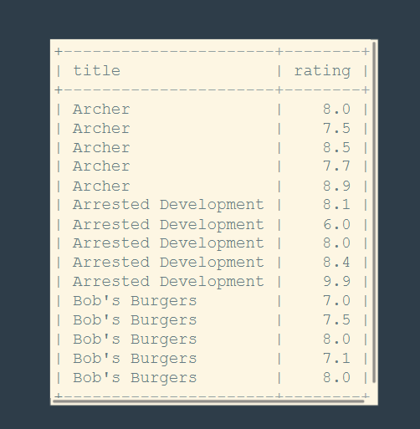

Challenge 2

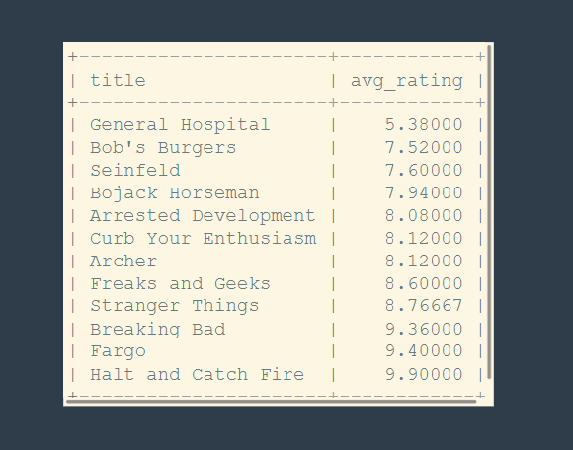

Challenge 3

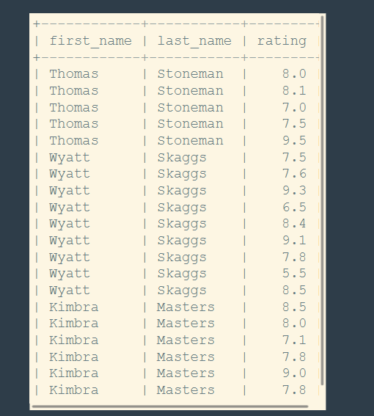

Challenge 4



Challenge 5

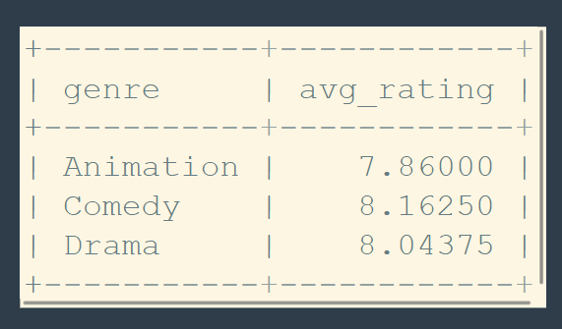

Challenge 6

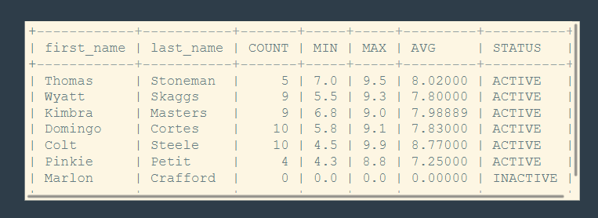

Challenge 7

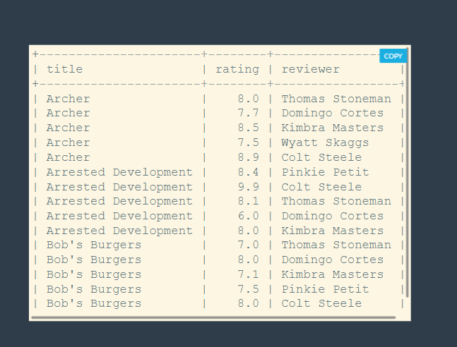

select title, rating from series

join reviews on series.id = reviews.series_id;

select title, ifnull(avg(rating), 0) as avg_rating from series

join reviews on series.id = reviews.series_id

group by title

order by avg_rating;

select first_name, last_name, rating from reviewers

join reviews on reviewers.id = reviews.reviewer_id;

select title as unreviewed_series from series

left join reviews on series.id = reviews.series_id

where rating is null;

select genre, ifnull(avg(rating), 0) as avg_rating from series

join reviews on series.id = reviews.series_id

group by genre;

select first_name, last_name,

ifnull(count(rating), 0) as count,

ifnull(min(rating), 0) as min,

ifnull(max(rating), 0) as max,

ifnull(avg(rating), 0) as 'avg',

case

when count(rating) > 0 then 'active'

else 'inactive'

end as 'status'

from reviewers

left join reviews on reviewers.id = reviews.reviewer_id

group by first_name, last_name;

select title, rating, concat(first_name, ' ', last_name) as reviewer from series

join reviews on series.id = reviews.series_id

join reviewers on reviewers.id = reviews.reviewer_id

order by title;